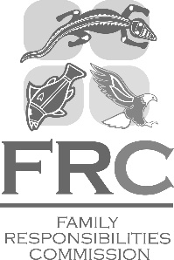 | Family Responsibilities Commission  Cairns Commonwealth Centre  Level 3, 107 Lake Street, Cairns  PO Box 5438  Cairns Qld 4870  Ph: 07 4081 8400  Fax: 07 4041 0974  www.frcq.org.au

30 September 2021

The Honourable Craig Crawford MP
Minister for Seniors and Disability Services and
Minister for Aboriginal and Torres Strait Islander Partnerships
PO Box 15397
CITY EAST QLD 4002

Dear Minister Crawford

I am pleased to submit for presentation to the Parliament the Annual Report 2020-21 including financial statements for the Family Responsibilities Commission.

I certify that this Annual Report complies with:
- the prescribed requirements of the Financial Accountability Act 2009 and the Financial and Performance Management Standard 2019, and
- the detailed requirements set out in the Annual Report Requirements for Queensland Government Agencies.

A checklist outlining the annual reporting requirements can be found at page 114 of this report.

Yours sincerely

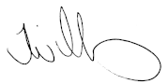
Tammy Williams
Commissioner
Family Responsibilities Commission

